DSA0504 – QUERY PROCESSING FOR DATA SCIENCE
ACTIVITY – 1
1.Program:
import pandas as pd
data= {'Name':['Jai','Princi','Gaurav','Anuj','Ravi','Natasha','Riya'],
'Age':[17,17,18,17,18,17,17],
'Gender':['M','F','M','M','M','F','F'],
'Marks':[90,76,'NaN',74,65,'NaN',71]}
df = pd.DataFrame(data)
df
Output:
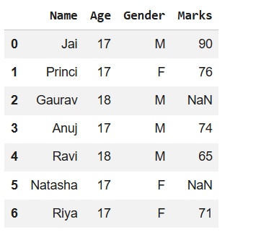

2.Program:
c = avg = 0
for ele in df['Marks']:
if str(ele).isnumeric():
c += 1
avg += ele
if c > 0:
avg /= c
df = df.replace(to_replace="NaN", value=avg)
df
Output:
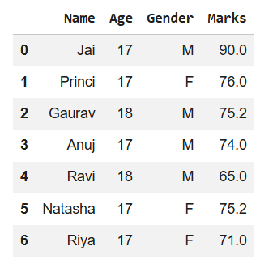
3.Program:
df['Gender'] = df['Gender'].map({'M': 0, 'F': 1}).astype(float)
df
Output:
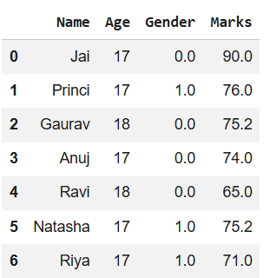

4.Program:
df = df[df['Marks'] >= 75].copy()
df.drop('Age', axis=1, inplace=True)
df
Output:
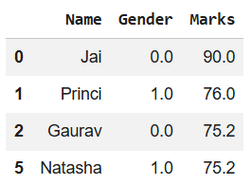

5.Program:
import pandas as pd

details = pd.DataFrame({
'ID': [101, 102, 103, 104, 105, 106,
107, 108, 109, 110],
'NAME': ['Jagroop', 'Praveen', 'Harjot',
'Pooja', 'Rahul', 'Nikita',
'Saurabh', 'Ayush', 'Dolly', "Mohit"],
'BRANCH': ['CSE', 'CSE', 'CSE', 'CSE', 'CSE',
'CSE', 'CSE', 'CSE', 'CSE', 'CSE']})

print(details)
Output:
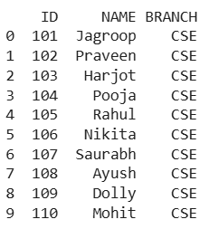

6.Program:
import pandas as pd
fees_status = pd.DataFrame(
{'ID': [101, 102, 103, 104, 105,
106, 107, 108, 109, 110],
'PENDING': ['5000', '250', 'NIL',
'9000', '15000', 'NIL',
'4500', '1800', '250', 'NIL']})
print(fees_status)
Output:
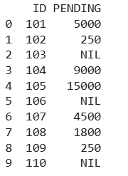
7.Program:
import pandas as pd
details = pd.DataFrame({
'ID': [101, 102, 103, 104, 105,
106, 107, 108, 109, 110],
'NAME': ['Jagroop', 'Praveen', 'Harjot',
'Pooja', 'Rahul', 'Nikita',
'Saurabh', 'Ayush', 'Dolly', "Mohit"],
'BRANCH': ['CSE', 'CSE', 'CSE', 'CSE', 'CSE',
'CSE', 'CSE', 'CSE', 'CSE', 'CSE']})
fees_status = pd.DataFrame(
{'ID': [101, 102, 103, 104, 105,
106, 107, 108, 109, 110],
'PENDING': ['5000', '250', 'NIL',
'9000', '15000', 'NIL',
'4500', '1800', '250', 'NIL']})
print(pd.merge(details, fees_status, on='ID'))
Output:
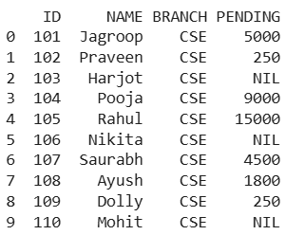
8.Program:
import pandas as pd
car_selling_data = {'Brand': ['Maruti', 'Maruti', 'Maruti',
'Maruti', 'Hyundai', 'Hyundai',
'Toyota', 'Mahindra', 'Mahindra',
'Ford', 'Toyota', 'Ford'],
'Year': [2010, 2011, 2009, 2013,
2010, 2011, 2011, 2010,
2013, 2010, 2010, 2011],
'Sold': [6, 7, 9, 8, 3, 5,
2, 8, 7, 2, 4, 2]}
df = pd.DataFrame(car_selling_data)
print(df)

Output:
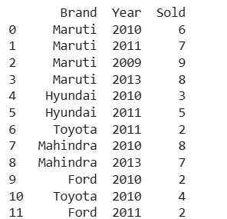

9.Program:
import pandas as pd
car_selling_data = {'Brand': ['Maruti', 'Maruti', 'Maruti',
'Maruti', 'Hyundai', 'Hyundai',
'Toyota', 'Mahindra', 'Mahindra',
'Ford', 'Toyota', 'Ford'],
'Year': [2010, 2011, 2009, 2013,
2010, 2011, 2011, 2010,
2013, 2010, 2010, 2011],
'Sold': [6, 7, 9, 8, 3, 5,
2, 8, 7, 2, 4, 2]}
df = pd.DataFrame(car_selling_data)
grouped = df.groupby('Year')
print(grouped.get_group(2010))
Output:
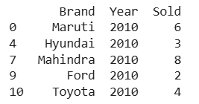
10.Program:
import pandas as pd
student_data = {'Name': ['Amit', 'Praveen', 'Jagroop',
'Rahul', 'Vishal', 'Suraj',
'Rishab', 'Satyapal', 'Amit',
'Rahul', 'Praveen', 'Amit']
'Roll_no': [23, 54, 29, 36, 59, 38,
12, 45, 34, 36, 54, 23],
'Email': ['xxxx@gmail.com', 'xxxxxx@gmail.com',
'xxxxxx@gmail.com', 'xx@gmail.com',
'xxxx@gmail.com', 'xxxxx@gmail.com',
'xxxxx@gmail.com', 'xxxxx@gmail.com',
'xxxxx@gmail.com', 'xxxxxx@gmail.com',
'xxxxxxxxxx@gmail.com', 'xxxxxxxxxx@gmail.com']}
df = pd.DataFrame(student_data)
print(df)
Output:
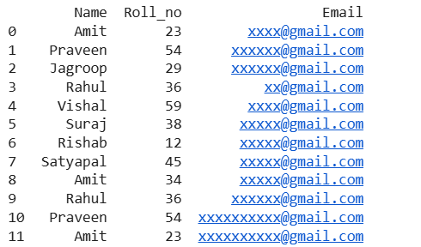
11.Program:
import pandas as pd
student_data = {'Name': ['Amit', 'Praveen', 'Jagroop',
'Rahul', 'Vishal', 'Suraj',
'Rishab', 'Satyapal', 'Amit',
'Rahul', 'Praveen', 'Amit'],
'Roll_no': [23, 54, 29, 36, 59, 38,
12, 45, 34, 36, 54, 23],
'Email': ['xxxx@gmail.com', 'xxxxxx@gmail.com',
'xxxxxx@gmail.com', 'xx@gmail.com',
'xxxx@gmail.com', 'xxxxx@gmail.com',
'xxxxx@gmail.com', 'xxxxx@gmail.com',
'xxxxx@gmail.com', 'xxxxxx@gmail.com',
'xxxxxxxxxx@gmail.com', 'xxxxxxxxxx@gmail.com']}
df = pd.DataFrame(student_data)
non_duplicate = df[~df.duplicated('Roll_no')]
print(non_duplicate)
Output:
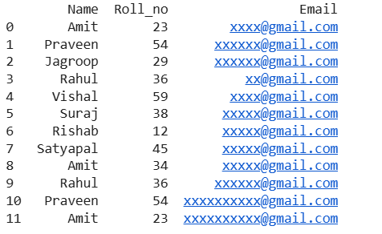
12.Program:
import pandas as pd
data1 = {'Name':['Jai', 'Princi', 'Gaurav', 'Anuj'],
'Age':[27, 24, 22, 32],
'Address':['Nagpur', 'Kanpur', 'Allahabad', 'Kannuaj'],
'Qualification':['Msc', 'MA', 'MCA', 'Phd'],
'Mobile No': [97, 91, 58, 76]}
data2 = {'Name':['Gaurav', 'Anuj', 'Dhiraj', 'Hitesh'],
'Age':[22, 32, 12, 52],
'Address':['Allahabad', 'Kannuaj', 'Allahabad', 'Kannuaj'],
'Qualification':['MCA', 'Phd', 'Bcom', 'B.hons'],
'Salary':[1000, 2000, 3000, 4000]}
df = pd.DataFrame(data1,index=[0, 1, 2, 3])
df1 = pd.DataFrame(data2, index=[2, 3, 6, 7])
res = pd.concat([df, df1])
res
Output:
